[ITI41120 Applied Computer Science Project](https://www.hiof.no/english/studies/courses/iio/itk/2023/spring/iti41120.html" \t "_blank)

**Topic**: Platooning small mobile robots in indoor track

**Research areas involved:** Cyber-physical systems, Image processing

**Skills needed:** Experience with MATLAB/Simulink, some basic experience with Raspberry Pi etc.

**Contact:** Maben Rabi ([maben.rabi@hiof.no](mailto:maben.rabi@hiof.no)),

Two students could work on this project.

**Content:** This is a project within the topic of Internet of Things (IoT) for vehicles. This is meant to produce an experimental setup that shall be used in the masters course ITI41920 during Autumn 2023.

The purpose of this project is to implement an algorithm for small Raspberry robots to form and maintain a platoon. The user specifies desired speed, and desired inter-vehicle distance. Each individual vehicle can: (i) use a camera to find the lane and keep to it, (ii) get wireless (Bluetooth/Wi-Fi) messages on the speeds and braking plans of other vehicles, and (iii) use the camera to estimate distance to the vehicle in front. Simulink shall be the development platform. The aim is to use automatic code generation from a Simulink block diagram.

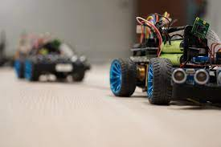

Figure : image source: Fraunhoffer blockchain lab